Assignment 1

Question 1:

Write a program to print the lines of a file that contain a word given as the

program argument (a simple version of grep UNIX utility).

Code:

#include<unistd.h>

#include<stdio.h>

#include<stdlib.h>

#include<string.h>

int main(int argc, char const *argv[])

{

int fd;

int i=0;

int k=0;

char ch[100];

char chr;

if(argc!=3)

{

printf("Insufficient arguments");

exit(1);

}

// if(fd=(open(argv[2],O_RDONLY))==-1)

// {

// printf("File is not there");

// exit(1);

// }

while((read(fd,&chr,1))>0)

{

if(chr!='\n')

{

ch[i]=chr;

i++;

}

else

{

k++;

ch[i]='\0';

i=0;

if(strstr(ch,argv[1])!=NULL)

{

printf("Line: %d\t %s\n",k,ch);

}

}

}

exit(0);

}

Output:

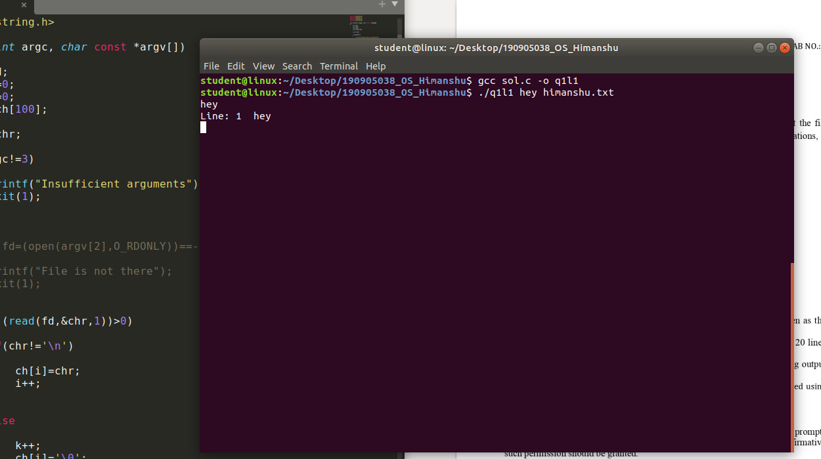

Question 2:

Write a program to list the files given as arguments, stopping every 20 lines

until a key is hit. (a simple version of more UNIX utility)

Code:

#include <stdio.h>

#include <unistd.h>

#include <sys/stat.h>

#include <fcntl.h>

#include <stdlib.h>

#include <string.h>

int main(int argc, char *argv[])

{

    int sfd, sfd2, i = 0, j = 0, k = 0;

    char s[100], s2[100], c;

    if(argc != 3)

    {

        printf("Arguments less than 3\n");

        exit(1);

    }

    if((sfd = open(argv[1], O_RDONLY)) == -1)

    {

        printf("File cannot be opened\n");

        exit(1);

    }

    while((read(sfd,&c,1)) > 0)

    {

        if(c != '\n')

        {

            s[i] = c;

            i++;

        }

        else

        {

            j++;

            k++;

            s[i] = '\0';

            i = 0;

            printf("Line: %d \t %s \n", k, s);

            if(j == 20)

            {

                // gets next character

                fgetc(stdin);

                j = 0;

            }

        }

    }

    close(sfd);

    if((sfd2 = open(argv[2], O_RDONLY)) == -1)

    {

        printf("File cannot be opened\n");

        exit(1);

    }

    k = 0;

    while((read(sfd, &c, 1))>0)

    {

        if(c != '\n')

        {

            s2[i] = c;

            i++;

        }

        else

        {

            j++;

            k++;

            s2[i] = '\0';

            i = 0;

            printf("l: %d \t %s \n", k, s2);

            if(j == 20)

            {

                fgetc(stdin);

                j = 0;

            }

        }

    }

    exit(0);

}

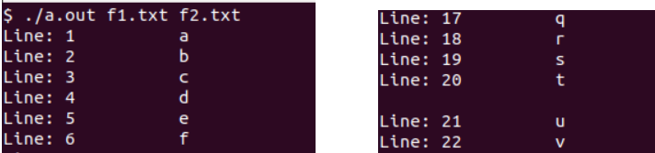

Question 3 :

Demonstrate the use of different conversion specifiers and resulting output

to allow the items to be printed.

Code:

#include<stdio.h>

#include<stdlib.h>

#include<errno.h>

int main()

{

    int a = 133;

    float b = 42.56;

    char c = 'q';

    char s[] = "This is a string";

    printf(" int = %d\n float = %f\n char = %c\n string = %s\n hex for int = %x\n exp for float = %e\n", a, b, c, s, a, b);

    return 0;

}

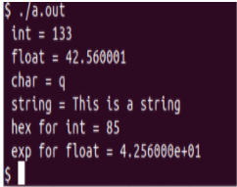

Question 4 :

Write a program to copy character-by character copy is accomplished using

calls to the functions referenced in stdio.h

Code:

#include<stdio.h>

#include <unistd.h>

#include<sys/stat.h>

#include<fcntl.h>

#include<stdlib.h>

int main(int argc, char *argv[])

{

    char c;

    int inp, outp;

    if(argc != 3)

    {

        printf("Arguments less than 3");

        exit(1);

    }

    inp = open(argv[1], O_RDWR);

    outp = open(argv[2], O_WRONLY|O_CREAT, S_IRUSR|S_IWUSR);

    if(inp == -1 || outp == -1)

    {

        printf("File cannot be opened\n");

        exit(1);

    }

    while(read(inp, &c, 1) == 1)

        write(outp, &c, 1);

    printf("Copied\n");

    exit(0);

}

F1 text contains a-z line by line

F2 is empty text

